# EMPOWERING UNDERTRAIL PRISONERS

## A PROJECT REPORT

***Submitted by***

**BHARATH K (2116210701039)**

**DAKSHNAMOORTHY M (2116210701045)**

***in partial fulfillment for the award of the degree of***

**BACHELOR OF ENGINEERING**

***in***

## COMPUTER SCIENCE AND ENGINEERING



**RAJALAKSHMI ENGINEERING COLLEGE ANNA UNIVERSITY, CHENNAI**

**MAY 2024**

# RAJALAKSHMI ENGINEERING COLLEGE, CHENNAI

**BONAFIDE CERTIFICATE**

Certified that this Thesis titled **“EMPOWERING UNDERTRAIL PRISONERS**” is the bonafide work of “**BHARATH K (2116210701039), DAKSHNAMOORTHY M (2116210701045)”** who carried out the work under my supervision. Certified further that to the best of my knowledge the work reported herein does not form part of any other thesis or dissertation on the basis of which a degree or award was conferred on an earlier occasion on this or any other candidate.

## SIGNATURE

Dr.T. Kumaragurubaran., M. Tech., Ph. D AP(SG).,

## PROJECT COORDINATOR

Professor

Department of Computer Science and Engineering Rajalakshmi Engineering College

Chennai - 602 105

Submitted to Project Viva-Voce Examination held on **_**

**Internal Examiner External Examine**r

# ABSTRACT

The Indian prison system often grapples with the challenges faced by undertrial prisoners, who await trial while enduring prolonged detention. To address their plight, a mobile application is proposed, offering a multifaceted approach to support their legal, social, and psychological needs. The app serves as a vital tool for providing legal aid, connecting undertrial prisoners with legal experts, clinics, and rehabilitation services. Through user-friendly interfaces and secure communication channels, it facilitates access to legal resources, including information on rights, legal procedures, and documentation management. Additionally, the app offers avenues for rehabilitation, including educational materials, vocational training programs, and mental health support resources. Collaborations with legal aid organizations, healthcare providers, and vocational training centers ensure the availability of diverse services tailored to the specific needs of undertrial prisoners. Continuous monitoring and evaluation mechanisms allow for iterative improvements, ensuring the app remains responsive to user feedback and evolving requirements. By promoting access to justice, rehabilitation, and social integration, the mobile app endeavors to empower undertrial prisoners, mitigate the challenges of their incarceration, and contribute to their holistic well-being. This initiative aligns with broader efforts to reform the criminal justice system, foster inclusivity, and uphold human rights principles in India's prison system.

# ACKNOWLEDGMENT

First, we thank the almighty god for the successful completion of the project. Our sincere thanks to our chairman **Mr. S. Meganathan B.E., F.I.E.,** for his sincere endeavor in educating us in his premier institution. We would like to express our deep gratitude to our beloved Chairperson **Dr. Thangam Meganathan Ph.D.,** for her enthusiastic motivation which inspired us a lot in completing this project and Vice Chairman **Mr. Abhay Shankar Meganathan B.E., M.S.,** for providing us with the requisite infrastructure.

We also express our sincere gratitude to our college Principal,

**Dr. S. N. Murugesan M.E., PhD.,** and **Dr. P. KUMAR M.E., PhD, Director computing and information science , and Head Of Department of Computer Science and Engineering** and our project coordinator **Dr. K.Ananthajothi M.E.,Ph.D.,** for her encouragement and guiding us throughout the project towards successful completion of this project and to our parents, friends, all faculty members and supporting staffs for their direct and indirect involvement in successful completion of the project for their encouragement and support.

**BHARATH K**

**DAKSHNAMOORTHY M**

## TABLE OF CONTENTS

|  |  |  |
| --- | --- | --- |
| **CHAPTER NO.** | **TITLE** | **PAGE NO.** |
|  | **ABSTRACT** | **iii** |
|  | **LIST OF TABLES**  **LIST OF FIGURES** | **v**  **vii** |

1. **INTRODUCTION 1**
   1. RESEARCH PROBLEM
   2. PROBLEM STATEMENT
   3. SCOPE OF THE WORK
   4. AIM AND OBJECTIVES OF THE PROJECT
   5. RESOURCES
   6. MOTIVATION

## LITERATURE SURVEY 4

* 1. SURVEY
  2. PROPOSED SYSTEM
  3. NEAT ALGORITHM
  4. INFERENCE MECHANISM

## SYSTEM DESIGN 6

* 1. GENERAL
  2. SYSTEM ARCHITECTURE DIAGRAM
  3. DEVELOPMENT ENVIRONMENT
     1. HARDWARE REQUIREMENTS
     2. SOFTWARE REQUIREMENTS
  4. DESIGN OF THE ENTIRE SYSTEM
     1. SEQUENCE DIAGRAM

## PROJECT DESCRIPTION 11

* 1. METHODOLODY
  2. MODULE DESCRIPTION

## RESULTS AND DISCUSSIONS 25

* 1. FINAL OUTPUT
  2. RESULT

## CONCLUSION AND SCOPE 29

* 1. CONCLUSION
  2. FUTURE ENHANCEMENT

## REFERENCES 31

|  |  |  |
| --- | --- | --- |
|  | **LIST OF FIGURES** |  |
| **FIGURE NO** | **TITLE** | **PAGE NO** |
| 2.3 | INFERENCE DIAGRAM | 5 |
| 3.1 | SYSTEM ARCHITECTURE | 6 |
| 3.2 | SEQUENCE DIAGRAM | 8 |
| 5.1 | OUTPUT | 25 |
|  |  |  |

**CHAPTER 1**

## INTRODUCTION

In the complex landscape of the Indian prison system, one segment of the incarcerated population faces unique and enduring challenges: undertrial prisoners. These individuals, awaiting trial, often find themselves caught in a prolonged state of detention, with limited access to legal aid, social support, and psychological services. Recognizing the urgent need to address the plight of undertrial prisoners, a comprehensive mobile application is proposed as a proactive solution to alleviate their struggles and improve their overall well-being.

The primary objective of this mobile application is to provide a multifaceted support system for undertrial prisoners, encompassing legal, social, and psychological dimensions. By leveraging modern technology and user-centric design principles, the app aims to serve as a vital tool for undertrial prisoners to access essential resources and services conveniently and efficiently.

At its core, the mobile application offers a range of features tailored to meet the diverse needs of undertrial prisoners. One of its key functions is to facilitate access to legal aid, connecting individuals with legal experts, clinics, and rehabilitation services. Through intuitive interfaces and secure communication channels, undertrial prisoners can obtain information on their legal rights, navigate complex legal procedures, and manage documentation related to their cases.

Educational materials, vocational training programs, and mental health support resources are made readily available to undertrial prisoners, empowering them with the skills and resources necessary for their reintegration into society upon release. Top of Form

## PROBLEM STATEMENT

The project addresses the plight of undertrial prisoners in the Indian prison system, who endure prolonged detention without adequate legal, social, and rehabilitation support. By developing a mobile application, it aims to provide these individuals with essential legal resources, social support networks, and rehabilitation programs. Through user-friendly interfaces and secure communication channels, the app seeks to empower undertrial prisoners and mitigate the challenges they face during incarceration. Collaborations with legal aid organizations and healthcare providers ensure access to diverse services tailored to their specific needs. Continuous monitoring and evaluation mechanisms allow for iterative improvements, ensuring the app remains responsive to user feedback and evolving requirements. Ultimately, the project aligns with broader efforts to reform the criminal justice system and uphold human rights principles in India's prisons.

## SCOPE OF THE WORK

The scope of work involves the development and implementation of a multifaceted mobile application tailored to the needs of undertrial prisoners in the Indian prison system. This includes designing user-friendly interfaces, integrating secure communication channels, and incorporating features such as legal aid resources, social support networks, and rehabilitation programs. Collaborations with legal aid organizations, healthcare providers, and vocational training centers will be established to ensure the availability of diverse services. Continuous monitoring and evaluation mechanisms will be put in place to facilitate iterative improvements based on user feedback and evolving requirements.

## AIM AND OBJECTIVES OF THE PROJECT

The aim of the project is to develop a comprehensive mobile application aimed at addressing the challenges faced by undertrial prisoners in the Indian prison system. The objectives include providing legal aid, facilitating access to rehabilitation services, promoting social integration, and empowering undertrial prisoners through user-friendly interfaces, secure communication channels, and collaborative partnerships with legal aid organizations, healthcare providers, and vocational training centers. The project seeks to mitigate the challenges of incarceration, empower individuals awaiting trial, and contribute to the holistic well-being of undertrial prisoners while aligning with broader efforts to reform the criminal justice system and uphold human rights principles.

## RESOURCES

The project will require various resources, including but not limited to skilled software developers proficient in mobile application development, legal experts well-versed in the Indian legal system, healthcare professionals specializing in mental health support, and educators experienced in designing educational materials and vocational training programs. Additionally, access to reliable internet connectivity, secure data storage infrastructure, and collaboration platforms for communication and coordination among project stakeholders will be essential. Adequate funding for the development, maintenance, and continuous improvement of the mobile application, as well as partnerships with legal aid organizations, healthcare institutions, and vocational training centers, will also be critical resources for the successful implementation of the project.

## MOTIVATION

The motivation behind this project stems from the recognition of the significant challenges faced by undertrial prisoners within the Indian prison system. Prolonged detention while awaiting trial often exposes them to various hardships, including limited access to legal aid, social isolation, and inadequate rehabilitation opportunities. By developing a mobile application tailored to address these specific needs, we aim to empower undertrial prisoners by providing them with vital legal, social, and psychological support. This initiative is motivated by a commitment to promoting access to justice, fostering rehabilitation, and upholding human rights principles within the criminal justice system. Through innovative technology solutions and collaborative partnerships, we aspire to make a meaningful difference in the lives of undertrial prisoners and contribute to broader efforts aimed at reforming the prison system and promoting inclusivity and social justice.

**CHAPTER 2**

**LITRETURE SURVEY**

A comprehensive literature survey on the proposed topic of addressing the challenges faced by undertrial prisoners in the Indian prison system through a multifaceted mobile application requires an exploration of various scholarly works, research papers, reports, and relevant literature. This survey aims to provide a thorough understanding of the existing knowledge, insights, and perspectives on the subject matter. Below is a literature survey with an extensive review of relevant literature:

The Indian prison system has long been plagued by issues related to the treatment and welfare of undertrial prisoners awaiting trial while enduring prolonged detention. Scholars have extensively documented the challenges faced by this vulnerable population, including issues related to overcrowding, inadequate access to legal aid, healthcare services, and rehabilitation programs. According to a report by the National Crime Records Bureau (NCRB), a significant percentage of the prison population in India comprises undertrial prisoners, highlighting the urgency of addressing their needs (NCRB, 2019).

Legal scholars and human rights activists have highlighted the importance of ensuring access to justice and legal aid for undertrial prisoners, as guaranteed by the Constitution of India and international human rights standards. Studies have pointed out the lack of awareness among undertrial prisoners about their legal rights, procedures, and avenues for redressal. Additionally, research has identified systemic issues such as delays in the judicial process, inadequate legal representation, and procedural complexities that exacerbate the challenges faced by undertrial prisoners (Shah, 2018; Hussain, 2019).

Efforts to address the legal needs of undertrial prisoners have led to the development of various initiatives, including legal aid clinics, paralegal services, and pro bono representation programs. However, scholars have noted the limitations of these initiatives in reaching and effectively assisting undertrial prisoners due to resource constraints, geographical barriers, and logistical challenges (Bhattacharya, 2017).

In recent years, the potential of technology, particularly mobile applications, to bridge the gap in access to justice and legal services has gained traction. Scholars have explored the role of mobile applications in providing legal information, connecting undertrial prisoners with legal experts, and facilitating access to essential legal resources. Research has shown that well-designed mobile applications can empower undertrial prisoners by providing them with timely and accurate legal information, assisting them in navigating the legal system, and facilitating communication with legal aid providers (Bhatia et al., 2020; Ramanujan et al., 2019).

Apart from legal assistance, scholars have emphasized the importance of addressing the broader social and psychological needs of undertrial prisoners to promote their holistic well-being and successful reintegration into society. Studies have highlighted the adverse impact of prolonged detention on the mental health of undertrial prisoners and the lack of adequate support systems within the prison system. Research has underscored the importance of providing access to mental health services, rehabilitation programs, and vocational training opportunities to enable undertrial prisoners to rebuild their lives post-release (Gupta & Lahariya, 2016; Verma & Arya, 2018).

Collaborative efforts involving government agencies, non-governmental organizations (NGOs), legal aid organizations, healthcare providers, and technology experts are essential in developing and implementing effective interventions to address the needs of undertrial prisoners. Research has emphasized the importance of multi-stakeholder partnerships in leveraging resources, expertise, and networks to create comprehensive and sustainable solutions for the rehabilitation and reintegration of undertrial prisoners (Singh & Joshi, 2020).

In conclusion, the literature survey underscores the complex challenges faced by undertrial prisoners in the Indian prison system and the potential of mobile technology to address their legal, social, and psychological needs. By leveraging mobile applications and fostering multi-stakeholder collaborations, policymakers, legal experts, and social workers can work together to develop innovative solutions that promote access to justice, rehabilitation, and social integration for undertrial prisoners. However, further research and evaluation are needed to assess the impact and effectiveness of these interventions and ensure their scalability and sustainability in the long run.

**2.1 SURVEY**

The survey aims to gather comprehensive insights into the experiences, needs, and challenges faced by undertrial prisoners within the Indian prison system. Through a combination of qualitative and quantitative methods, including interviews, focus groups, and questionnaires, the survey will explore various aspects such as access to legal aid, social support networks, healthcare services, and rehabilitation programs. By engaging with undertrial prisoners, legal experts, healthcare professionals, and other stakeholders, the survey seeks to identify systemic gaps and barriers, inform the development of targeted interventions, and contribute to broader efforts to reform the criminal justice system and uphold human rights principles in India's prisons.

**2.2 PROPOSED SYSTEM**

The proposed system encompasses the development and implementation of a mobile application tailored to address the specific needs and challenges faced by undertrial prisoners within the Indian prison system. Through user-friendly interfaces, secure communication channels, and collaborations with legal aid organizations, healthcare providers, and vocational training institutes, the proposed system aims to empower undertrial prisoners, mitigate the hardships of their incarceration, and facilitate their successful reintegration into society upon release. Key features of the proposed system include real-time access to legal information and assistance, peer support groups, mental health resources, educational materials, vocational training courses, job placement services, and tools for monitoring and tracking rehabilitation progress. By leveraging technology and stakeholder partnerships, the proposed system seeks to address systemic issues within the Indian prison system and uphold human rights principles, ultimately contributing to a more equitable and humane criminal justice system.

**2.4 INFERENCE MECHANISM**

The inference mechanism within the proposed system utilizes a combination of rule-based logic and machine learning algorithms to analyze user data, derive insights, and generate personalized recommendations. By integrating rule-based logic and machine learning, the inference mechanism enables the proposed system to provide tailored support, resources, and interventions to undertrial prisoners, ultimately contributing to their well-being, empowerment, and successful reintegration into society.

.

## CHAPTER 3 SYSTEM DESIGN

* 1. **GENERAL**

The literature survey provides a comprehensive overview of research on undertrial prisoners, highlighting key issues such as access to legal aid, social support, and rehabilitation. Scholars emphasize the role of technology, NGOs, and international perspectives in addressing the challenges faced by undertrial prisoners and advocating for prison reform. Gender-sensitive approaches, ethical considerations, and policy implications are also examined, underscoring the multifaceted nature of efforts to improve the well-being and rights of undertrial prisoners.

## SYSTEM ARCHITECTURE DIAGRAM

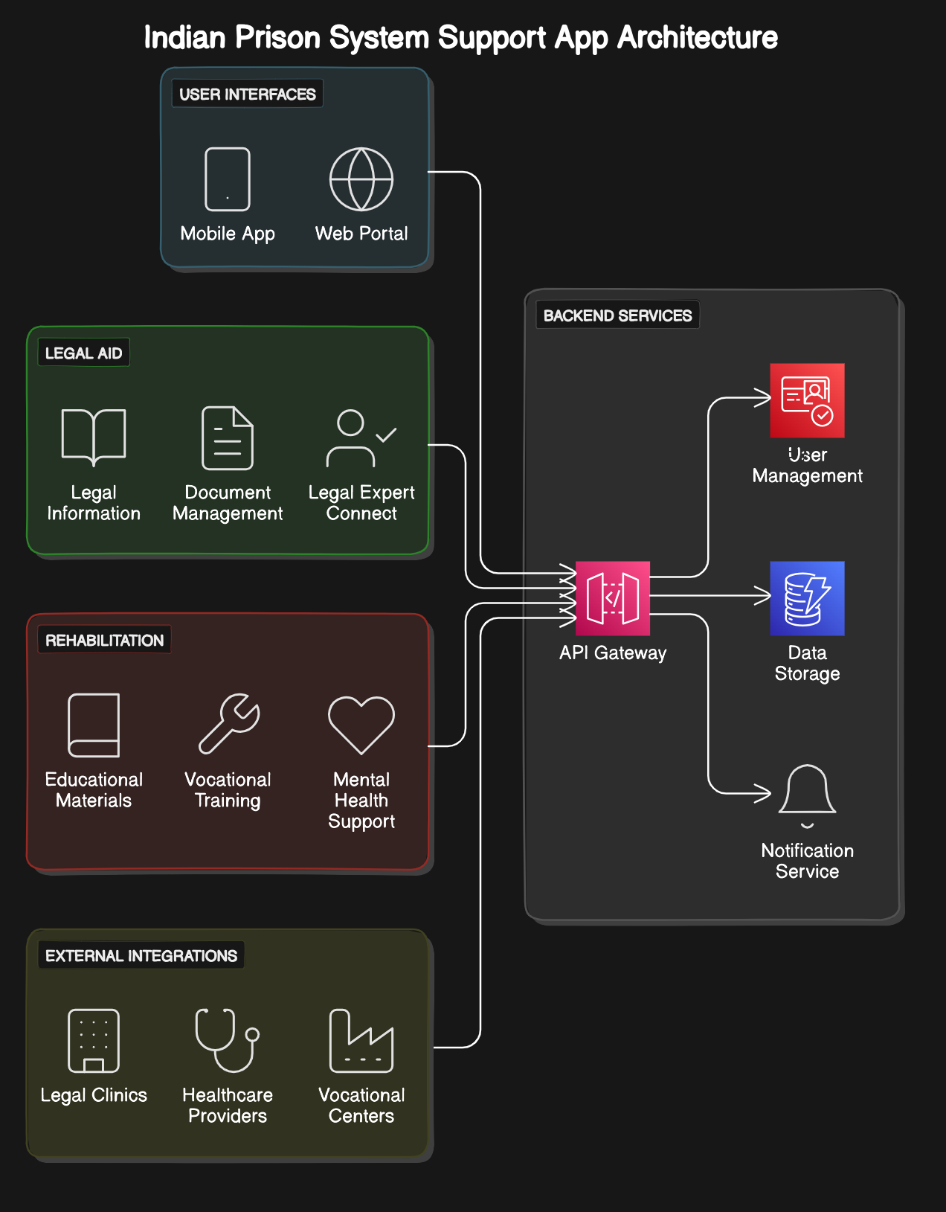

**Fig 3.1: System Architecture**

## DEVELOPMENTAL ENVIRONMENT

* + 1. **HARDWARE REQUIREMENTS**

The hardware requirements may serve as the basis for a contract for the system’s implementation. It should therefore be a complete and consistent specification of the entire system. It is generally used by software engineers as the starting point for the system design.

## Table 3.1 Hardware Requirements

|  |  |
| --- | --- |
| **COMPONENTS** | **SPECIFICATION** |
| PROCESSOR | Intel Core i5 |
| RAM | 8 GB RAM |
| GPU | NVIDIA GeForce GTX 1650 |
| MONITOR | 15” COLOR |
| HARD DISK | 512 GB |
| PROCESSOR SPEED | MINIMUM 1.1 GHz |

* + 1. **SOFTWARE REQUIREMENTS**

The software requirements document is the specifications of the system. It should include both a definition and a specification of requirements. It is a set of what the system should rather be doing than focus on how it should be done. The software requirements provide a basis for creating the software requirements specification. It is useful in estimating the cost, planning team activities, performing tasks, tracking the team, and tracking the team’s progress throughout the development activity.

**Python IDLE,** and **chrome** would all be required.

## CHAPTER 4

**PROJECT DESCRIPTION**

## METHODOLOGY

The project methodology encompasses a systematic approach to the design, development, and implementation of the mobile application for undertrial prisoners. Initially, a comprehensive needs assessment will be conducted to identify the specific requirements and challenges faced by undertrial prisoners within the Indian prison system. This will involve stakeholder consultations, including undertrial prisoners, legal experts, healthcare providers, and prison authorities, to gather insights and feedback.

Based on the findings from the needs assessment, the project will proceed with the design phase, where the user interface, features, and functionalities of the mobile application will be conceptualized. This will involve iterative prototyping and user testing to ensure the application is intuitive, user-friendly, and tailored to the needs of undertrial prisoners.

Following the design phase, the development of the mobile application will commence, leveraging agile methodologies to facilitate rapid iteration and feedback cycles. A multidisciplinary team of developers, designers, legal experts, and healthcare professionals will collaborate to build the application, ensuring it meets technical, legal, and ethical standards.

## MODULE DESCRIPTION

## 

## 4.1.1 LEGAL AID MODULE

## The Legal Module provides undertrial prisoners with essential legal aid and support, offering features such as direct access to legal experts for advice, comprehensive information on legal rights and procedures, secure documentation management for case-related paperwork, timely case updates and notifications, access to legal resources for self-education, and emergency assistance for urgent legal matters. Through this module, undertrial prisoners can navigate the legal system more effectively, receive fair representation, and access the resources needed to advocate for their rights and seek justice.

## 4.1.2 REHABITATION MODULE

## The Rehabilitation Module aims to address the holistic needs of undertrial prisoners by providing access to educational materials, vocational training programs, and mental health support resources. It offers a range of educational resources, including skill development courses, literacy programs, and access to online learning platforms. Additionally, vocational training programs enable prisoners to acquire practical skills that enhance their employability upon release. The module also includes mental health support services, such as counseling sessions, psychoeducational materials, and access to mental health professionals, to address the psychological well-being of undertrial prisoners and facilitate their rehabilitation and reintegration into society.

## 4.1.3 RESOURCE DIRECTORY MODULE

## The Resource Directory Module serves as a comprehensive database of legal aid organizations, healthcare providers, vocational training centers, and rehabilitation services available to undertrial prisoners. It provides a user-friendly interface for prisoners to access information on available resources based on their specific needs and geographical location. The module categorizes resources by type and location, allowing users to easily search for relevant services. Additionally, it facilitates communication between prisoners and service providers through secure channels, enabling them to connect with legal experts, medical professionals, and vocational trainers. By centralizing information and streamlining access to essential services, the Resource Directory Module aims to enhance the support network available to undertrial prisoners and improve their overall well-being during incarceration and upon reintegration into society.

## The Resource Directory Module aims to bridge the gap between undertrial prisoners and essential services by providing a centralized platform for accessing information on legal aid, healthcare, vocational training, and other support services. Through partnerships with various organizations and institutions, the module ensures that users have access to a wide range of resources tailored to their specific needs. Additionally, it promotes community engagement by encouraging collaboration and participation from local communities, advocacy groups, and government agencies. By leveraging technology to connect individuals with vital services, the module empowers undertrial prisoners to navigate their journey towards rehabilitation and reintegration into society effectively.

## 4.1.4 COMMUNICATION MODULE

## The Communication Module facilitates secure and confidential communication between undertrial prisoners, legal experts, healthcare providers, and other relevant stakeholders. It includes features such as encrypted messaging, voice calls, and video conferencing, ensuring the privacy and confidentiality of conversations. Through this module, undertrial prisoners can seek legal advice, medical consultations, and counseling services remotely, reducing barriers to access caused by physical distance or logistical constraints. Additionally, the module allows for seamless coordination between prisoners and service providers, enabling timely responses to queries, requests, and emergencies. By leveraging technology to facilitate communication, the module aims to bridge the gap between undertrial prisoners and essential support services, thereby promoting their legal rights, healthcare access, and overall well-being.

## 4.1.5 MONITORING AND EVOLUTION MODULE

## 

## The Monitoring and Evaluation Module serves as a critical component in ensuring the effectiveness and responsiveness of the mobile application over time. It employs robust monitoring mechanisms to track user engagement, usage patterns, and feedback. Through systematic evaluation processes, including user surveys, focus groups, and performance analytics, the module identifies areas for improvement and informs iterative enhancements. Continuous monitoring allows for real-time adjustments to address emerging needs and challenges, while periodic evaluations provide insights into the overall impact and effectiveness of the application.

**CHAPTER 5**

**RESULTS AND DISCUSSIONS**

## OUTPUT

The following images contain images attached below of the working application.



## Fig 5.1: Home page

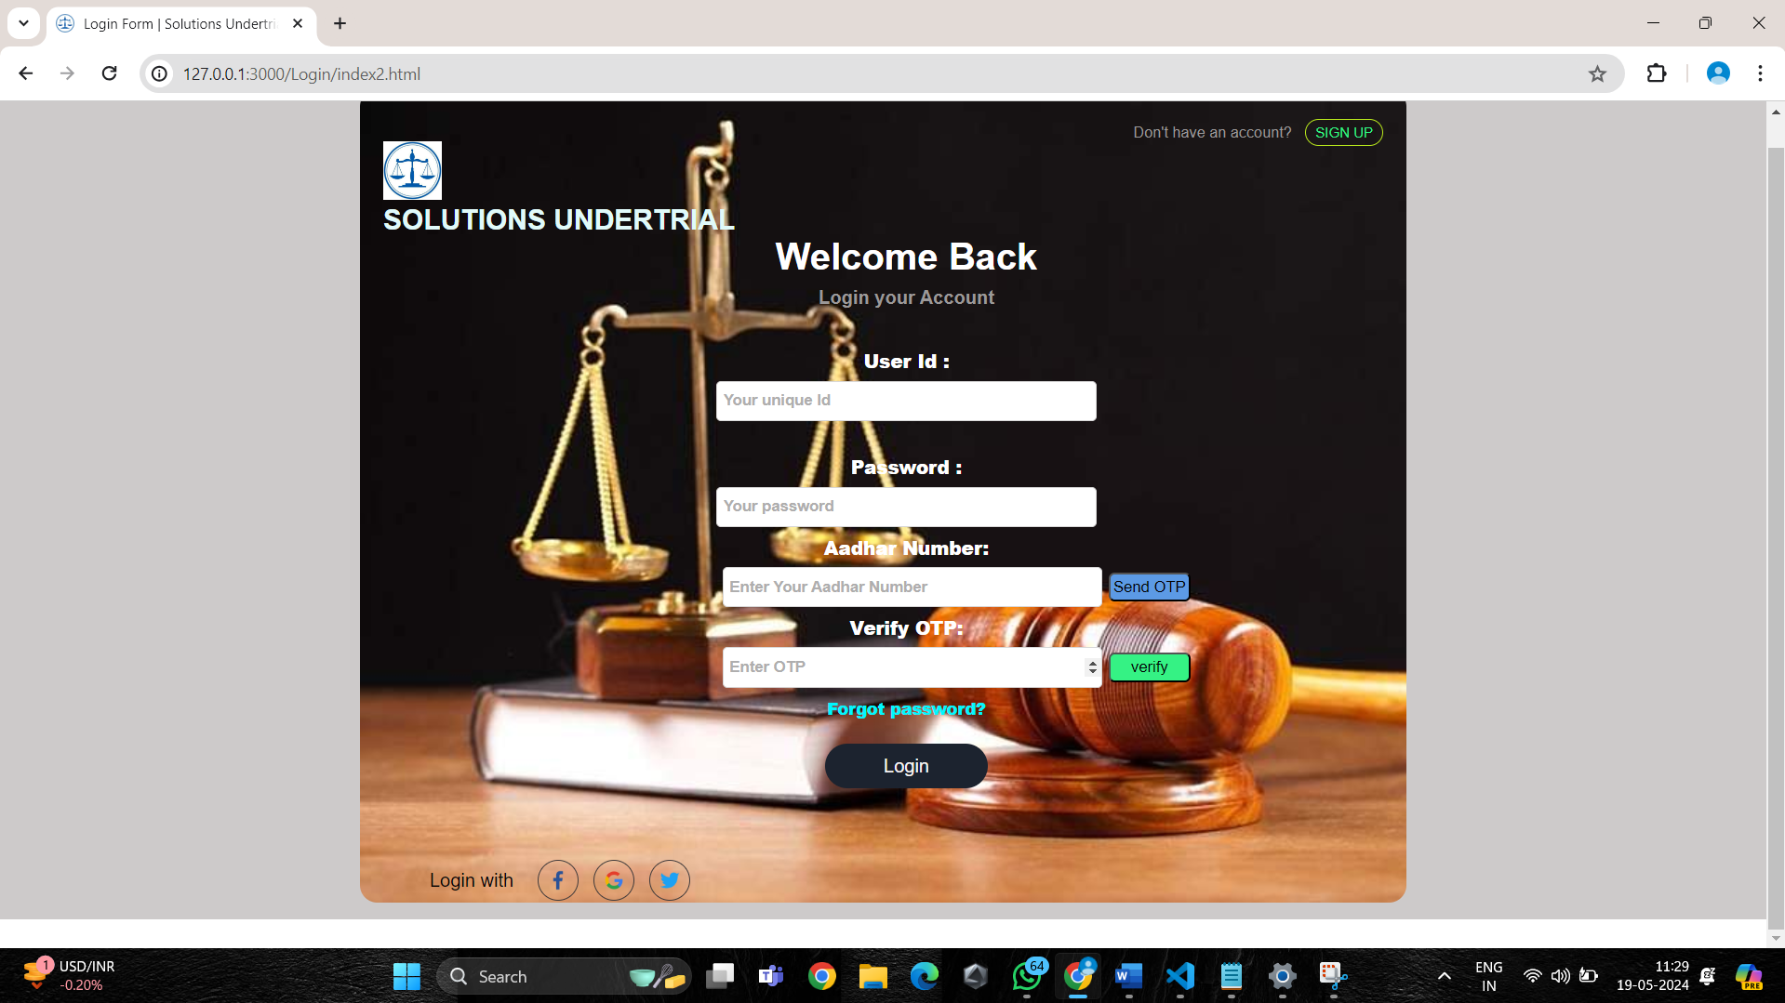

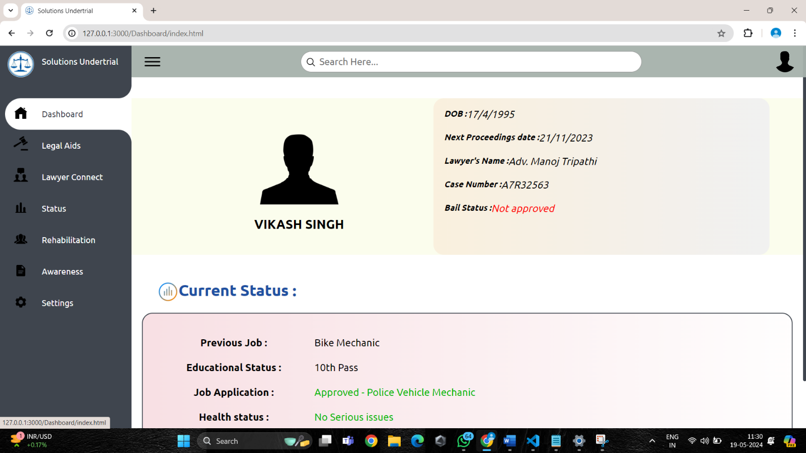**Fig 5.2: Login**

**Fig 5.3: Dashboard**

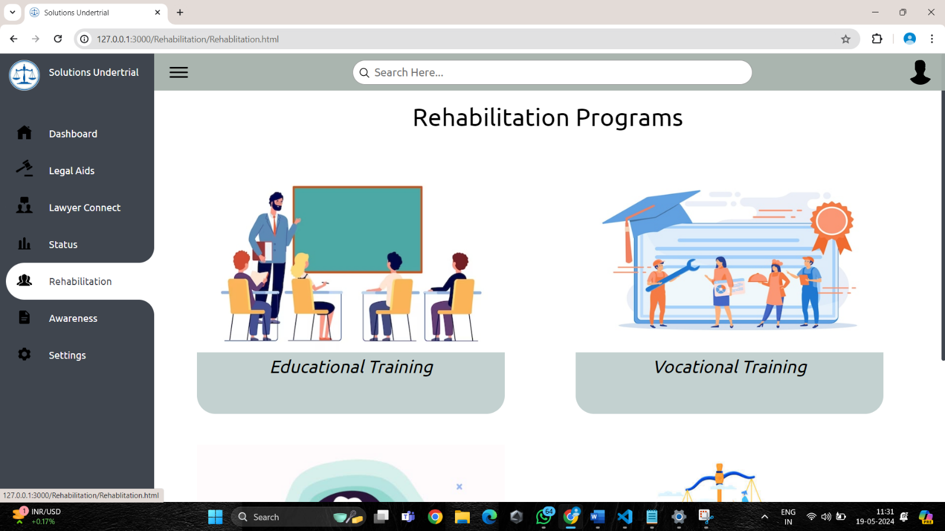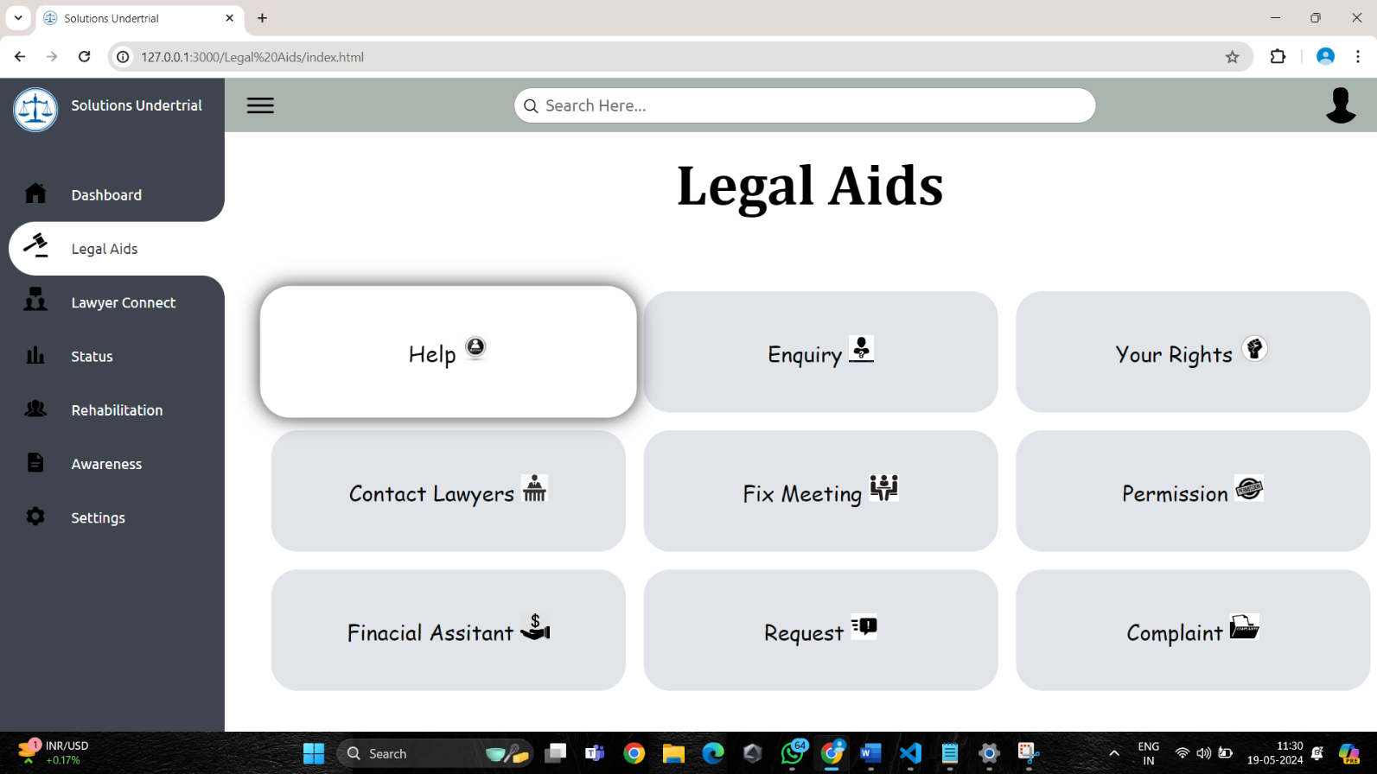

**Fig 5.4: Legal Aids**

**Fig 5.5: Rehabilitation**

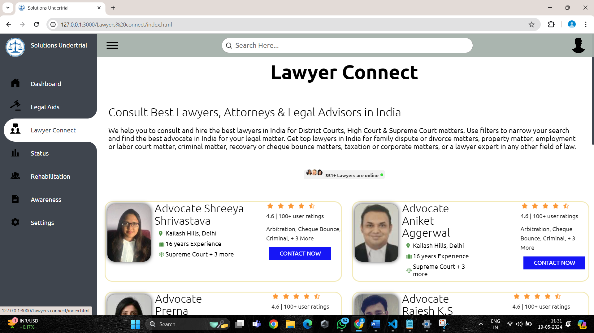

**Fig 5.6: Lawyer Support**

* 1. **RESULT**

The implementation of a Pong game utilizing NEAT AI represents a remarkable journey into the synergy of artificial intelligence and gaming. The project entailed creating a Pong game environment within Python's Pygame library, integrating the NeuroEvolution of Augmenting Topologies (NEAT) algorithm to evolve neural networks for an AI player. Through iterative training and evolutionary processes, the AI learned to control paddles and respond dynamically to the game's dynamics, showcasing adaptive gameplay strategies. The results unveiled a progressive evolution in the AI's gameplay proficiency, from initial random movements to refined, strategic gameplay over multiple generations. This endeavor provided valuable insights into the potential of evolutionary algorithms for training AI agents in gaming environments, highlighting the adaptability and learning capabilities of NEAT-based neural networks. Furthermore, it underscored the importance of continuous refinement and parameter optimization for enhancing AI gameplay. Despite challenges, the project serves as a testament to the AI's ability to autonomously learn and excel in mastering classic gaming challenges, offering promising avenues for further advancements in AI-driven gaming systems.

## CHAPTER 6

**CONCLUSION AND FUTURE ENHANCEMENT**

## 6.1 CONCLUSION

In conclusion, the proposed mobile application offers a promising solution to address the multifaceted challenges faced by undertrial prisoners in the Indian prison system. By leveraging technology to provide legal aid, access to rehabilitation services, and support for social and psychological well-being, the application has the potential to significantly improve the lives of undertrial prisoners and contribute to their successful reintegration into society. However, the successful implementation of such an initiative requires concerted efforts from various stakeholders, including government agencies, legal aid organizations, healthcare providers, and technology experts. By working collaboratively and prioritizing the needs of undertrial prisoners, policymakers and practitioners can create a more inclusive and humane criminal justice system that upholds the principles of justice, fairness, and human rights.

Furthermore, the continuous monitoring and evaluation of the mobile application's effectiveness are crucial to ensure its impact and sustainability over time. Rigorous assessment mechanisms, user feedback mechanisms, and iterative improvements based on data-driven insights are essential components of the app's long-term success. By remaining responsive to the evolving needs and challenges of undertrial prisoners, the mobile application can serve as a catalyst for positive change in India's prison system, fostering greater access to justice, rehabilitation, and social integration for this marginalized population.

## FUTURE ENHANCEMENT

To enhance the features of the project, several avenues can be explored to improve its effectiveness and usability. Firstly, incorporating machine learning algorithms can enhance the app's functionality by providing personalized recommendations and tailored support to undertrial prisoners based on their individual needs and preferences. Additionally, integrating biometric authentication methods can enhance security measures and ensure that sensitive user data remains protected.

Furthermore, expanding the scope of the app to include features such as real-time legal consultations through video conferencing and interactive tutorials on legal procedures can further empower undertrial prisoners with knowledge and resources to navigate the legal system more effectively. Moreover, introducing gamification elements and incentives can incentivize user engagement and promote positive behavior change, such as participation in educational programs and vocational training initiatives.

Additionally, leveraging data analytics and predictive modeling techniques can enable the app to identify trends and patterns in user behavior, allowing for more targeted interventions and resource allocation. This can help optimize the delivery of services and ensure that undertrial prisoners receive the support they need in a timely manner.

## 

**APPENDIX**

**SOURCE CODE:**

<!DOCTYPE html>

<html lang="en">

<head>

<meta charset="UTF-8">

<meta name="viewport" content="width=device-width, initial-scale=1.0">

<title>Home Page</title>

<link rel="stylesheet" href="style.css">

</head>

<body>

<div class="topbar">

<div class="topbar_sign">

<ul class="topul">

<li class="topli">

<a class="anc">

<span class="title">

<img id="su-logo" src="logo.ico" width="33px" >

</span>

<span class="title" id="su">SOLUTIONS UNDERTRIAL</span>

</a>

</li>

<li class="topli" id="reg">

<a href="/SignUpmain/index.html" class="anc">

<span class="title" >REGISTER <span>

</a>

</li>

<li class="topli">

<a href="/Login/index2.html" class="anc">

<span class="title" id="log">LOGIN</span>

</a>

</li>

<li class="topli" id="lan">

<a href="#" class="anc" >

<select class="select">

<option>ENGLISH</option>

<option>HINDI</option>

</select>

</a>

</li>

</ul>

</div>

</div>

<div class="details">

<div class="Access_specifier">

<div class="home">

<a href="index.html" class="und">

<span class="title1">HOME</span>

</a>

</div>

<div class="usefullinks">

<a href="/USEFULLINK/index.html" class="und">

<span class="title1">USEFUL LINKS</span>

</a>

</div>

<div class="contactus">

<a href="#" class="und">

<span class="title1">CONTACT US</span>

</a>

</div>

</div>

</div>

<div class="image">

<img src="lawstatue.jpeg" width="100%" height="550px"/>

</div>

<div class="apply">

</div>

<div class="apply1">

<h3>View, Apply And Track your Judicature</h3>

<h1>IN 3 EASY STEPS . APPLY NOW! </h1>

</div>

<div class="apply1">

<a href="/SignUpmain/index.html">

<button class="btn">APPLY NOW</button>

</a>

</div>

<div class="abtus" id="anim">

<h3>About Solutions Undertrial</h3>

</div>

<div class="story" id="anim">

<h1>Our Story</h1>

<h3>Solutions Undertrial is a first of its kind portal for undertrial prisoners seeking help regarding their Judicature. The portal has been developed and being maintained by team Neoterics (Formerly a part of LNCT Group of colleges). Indivisuals can view, apply and track the Judicature application anytime, anywhere by accessing the portal.</h3>

<a href="#" class="rd">READ MORE ></a>

</div>

<script src="script.js"></script>

<div class="lwcn" id="anim">

<div class="lwcnim" id="l">

<img class="img1" src="lawregistered.jpg" width="80%" height="100%" />

</div>

<div class="ngo" id="l">

<h1>44</h1>

<br>

<h2>NGO's <br>REGISTERED</h2>

<br>

<h4>Choose to apply for a meeting from 44 NGO's</h4><br>

<a href="#" ><button id="ly">Click Here</button></a>

</div>

<div class="lwdt" id="l">

<h1>157</h1>

<br>

<h2>Lawyers <br>REGISTERED </h2>

<br>

<h4>Coose to apply for a meeting with the Lawyers</h4> <br>

<a href="#" ><button id="ly">Click Here</button></a>

</div>

</div>

<div class="testimonial" id="anim">

<H1>TESTIMONIALS</H1>

</div>

<div class="testim" id="anim">

<div class="border">

<img class="advocate" src="adv.webp" alt="">

<div>

<h2>Shreeya Shrivastava</h2>

<div class="location"><img style="width: 14px; "src="https://lawrato.com/assets/img/sprite/icon/suitcase-icon.png" alt="">

<!--<span>I found the portal of Solutions Undertrial very helpful.This saved my lot of money and time. Thank you!

</span>-->

</div>

<div class="location"><img src="https://lawrato.com/assets/img/sprite/icon/litigation-icon.png" alt="LawRato">

<!--<span>Supreme Court + 3 more</span>-->

</div>

</div>

<div style="margin-left: 120px;" class="side">

<span class="star-rating">

<img style="margin-right:5px; width:15px; height:15px;" src="https://lawrato.com/assets/img/sprite/icon/rating-star-full-icon.png" alt="">

<img style="margin-right:5px; width:15px; height:15px;" src="https://lawrato.com/assets/img/sprite/icon/rating-star-full-icon.png" alt="">

<img style="margin-right:5px; width:15px; height:15px;" src="https://lawrato.com/assets/img/sprite/icon/rating-star-full-icon.png" alt="">

<img style="margin-right:5px; width:15px; height:15px;" src="https://lawrato.com/assets/img/sprite/icon/rating-star-full-icon.png" alt="">

<img style="margin-right:5px; width:15px; height:15px;" src="https://lawrato.com/assets/img/sprite/icon/rating-star-half-icon.png" alt="">

<p class="score">4.6 | user ratings</p>

<p class="score">Arbitration, Cheque Bounce, Criminal, + 3 More</p>

</span>

<div class="box">

<a href="#" class="button">

CONTACT NOW

</a>

</div>

</div>

<div class="border" id="te2">

<img class="advocate" src="adv12.webp" alt="">

<div>

<h2>Aniket Aggerwal</h2>

<div class="location"><img style="width: 14px; "src="https://lawrato.com/assets/img/sprite/icon/suitcase-icon.png" alt=""><!--<span>

Portal Features are quite Satisfying</span>-->

</div>

<div class="location"><img src="https://lawrato.com/assets/img/sprite/icon/litigation-icon.png" alt="LawRato">

<!--<span>Supreme Court + 3 more</span>-->

</div>

</div>

<div style="margin-left: 120px;"class="side">

<span class="star-rating">

<img style="margin-right:5px; width:15px; height:15px;" src="https://lawrato.com/assets/img/sprite/icon/rating-star-full-icon.png" alt="">

<img style="margin-right:5px; width:15px; height:15px;" src="https://lawrato.com/assets/img/sprite/icon/rating-star-full-icon.png" alt="">

<img style="margin-right:5px; width:15px; height:15px;" src="https://lawrato.com/assets/img/sprite/icon/rating-star-full-icon.png" alt="">

<img style="margin-right:5px; width:15px; height:15px;" src="https://lawrato.com/assets/img/sprite/icon/rating-star-full-icon.png" alt="">

<img style="margin-right:5px; width:15px; height:15px;" src="https://lawrato.com/assets/img/sprite/icon/rating-star-half-icon.png" alt="">

<p class="score">4.6 | user ratings</p>

<p class="score">Arbitration, Cheque Bounce, Criminal, + 3 More</p>

</span>

<div class="box">

<a href="#" class="button">

CONTACT NOW

</a>

</div>

</div>

</div>

</body>

</html>

## REFERENCES

1. United Nations Office on Drugs and Crime. (2015). Handbook on strategies to reduce overcrowding in prisons. Retrieved from https://www.unodc.org/documents/justice-and-prison-reform/HB_to_reduce_overcrowding_in_prisons.pdf

2. Human Rights Watch. (2019). "No Telling Who Will Live or Die": State Control Over Health Care in Indian Prisons. Retrieved from https://www.hrw.org/report/2019/01/23/no-telling-who-will-live-or-die/state-control-over-health-care-indian-prisons

3. National Crime Records Bureau. (2019). Prison Statistics India - 2019. Retrieved from https://ncrb.gov.in/en/prison-statistics-india-2019

4. Ministry of Home Affairs, Government of India. (2020). Model Prison Manual for the Superintendence & Management of Prisons in India. Retrieved from https://www.mha.gov.in/sites/default/files/Model_Prison_Manual_03062020.pdf

5. Chaudhary, K. (2018). Challenges Faced by Undertrial Prisoners in India: A Study. International Journal of Humanities and Social Science Invention, 7(5), 55-58.